Computer Programming Using Python 2.7 - Console 5 - List Statement
GOALS: Use Booleans and nested statements (indented twice or more under a conditional that is under another conditional).
- Open IDLE, File, New Window
- File, Save As, Computer, H:, console5list.py
- Type the following:
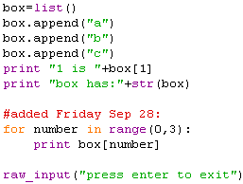

- Click Run, Run Module

